1.Set up an account(login with GitHub) and in the default project create a deployment for Kubernetes with GitOps.

2. I copied the repository link that is shown in the lab and connected to it.

After that, we connect to the cluster we want to deploy.

3. The review of the setup.

After that review all the tabs of the project and in the tab app details I changed the app to automated sync. This means, when any changes happen to your GitHub repo, the GitOps agent will pick those changes automatically and syncing will happen in an automated fashion.

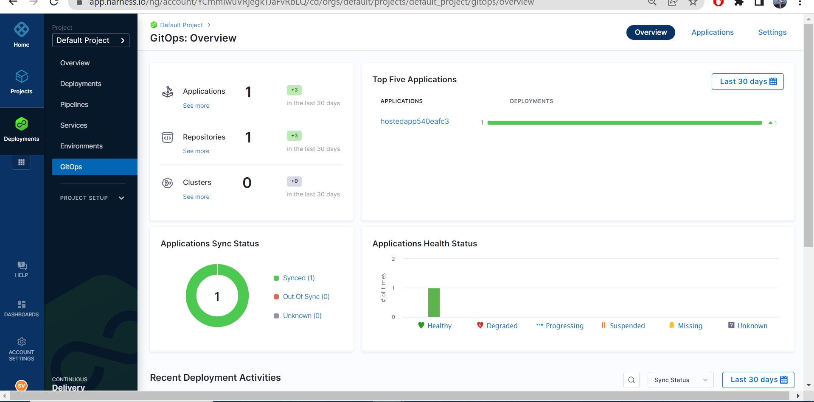

GitOps overview. After that, I tried changing the replicas to 4, 5, 6

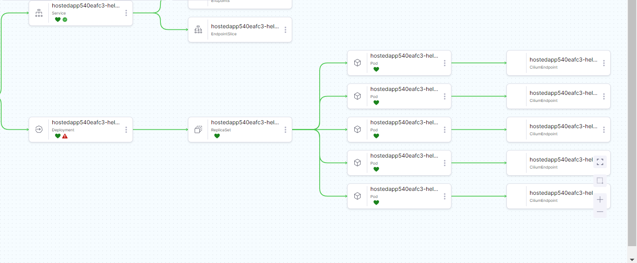

After applying all the changes I had to redeploy the app so that sync would be successful.